Buffalo Soldiers Motorcycle Club

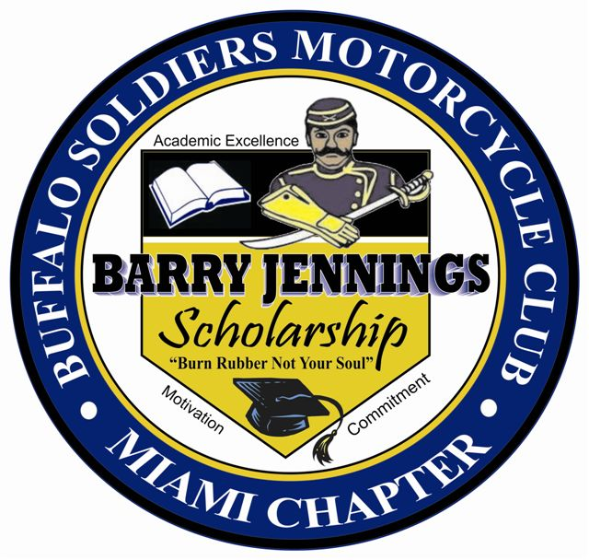
Miami Florida, Inc.

2021
Barry Jennings
College Scholarship Application
Application Deadline
April 09, 2021

Point of contact for additional questions or information:
Lenora Banks – Scholarship Chairperson
954-609-6961- ldbanks001@gmail.com
Buffalo Soldiers Motorcycle Club
Miami Florida, Inc.

Purpose:
The National Association of Buffalo Soldiers and Troopers Motorcycle Club (NABSTMC) is a National Organization dedicated to educating the public on the history of the original Buffalo Soldiers and their contribution to the growth of this country. The NABSTMC, through the establishment of local Chapters, contributes to the continued growth of the country by assisting and giving back to the local communities, providing positive role models to the youth, and supporting other charitable causes. The NABSTMC is continuously growing and to date has over a hundred (100) Chapters throughout the United States and overseas (including Hawaii and Korea).

The Miami Florida Chapter:
The Buffalo Soldiers Motorcycle Club, Miami Florida, Inc. was chartered in September 2006 as the 53rd Chapter of the NABSTMC. The Miami Chapter is a registered 501(c)(3); our charter includes educating the public in the rich history of the Buffalo Soldiers, servicing the community, supporting other non-profit organizations, promoting safe motorcycle riding, and riding in support of charitable events. Our Chapter fosters unity and brings motorcyclists in the Miami-Dade County, Broward County and the Florida Keys together for motorcycle related activities, such as mini excursions, club rallies and other forms of motorcycling fellowship. We ride under the name “Buffalo Soldiers” to express our pride and respect for the many accomplishments the Buffalo Soldiers made during and following the Civil War. We exist to continue the tradition of service to the nation as established by our military ancestors.
􀁔 􀁔􀁨􀁩􀁳􀀠􀁣􀁨􀁡􀁰􀁴􀁥􀁲􀀠􀁨􀁡􀁳􀀠􀁢􀁥􀁥􀁮􀀠􀁥􀁳􀁴􀁡􀁢􀁬􀁩􀁳􀁨􀁥􀁤􀀠􀁦􀁯􀁲􀀠􀁴􀁨􀁥􀀠􀁰􀁵􀁲􀁰􀁯􀁳􀁥􀀠􀁯􀁦􀀠
􀁦􀁯􀁳􀁴􀁥􀁲􀁩􀁮􀁧􀀠􀁵􀁮􀁩􀁴􀁹􀀬􀀠􀁡􀁮􀁤􀀠􀁢􀁲􀁩􀁮􀁧􀁩􀁮􀁧􀀠􀁭􀁯􀁴􀁯􀁲􀁣􀁹􀁣􀁬􀁩􀁳􀁴􀁳􀀠􀁩􀁮􀀠􀁴􀁨􀁥􀀠
􀁍􀁩􀁡􀁭􀁩􀀭􀁄􀁡􀁤􀁥􀀠􀁃􀁯􀁵􀁮􀁴􀁹􀀬􀀠􀁂􀁲􀁯􀁷􀁡􀁲􀁤􀀠􀁃􀁯􀁵􀁮􀁴􀁹􀀠􀁡􀁮􀁤􀀠􀁴􀁨􀁥􀀠􀁆􀁬􀁯􀁲􀁩􀁤􀁡􀀠
􀁋􀁥􀁹􀁳􀀠􀁡􀁲􀁥􀁡􀁳􀀠􀁴􀁯􀁧􀁥􀁴􀁨􀁥􀁲􀀠􀁦􀁯􀁲􀀠􀁭􀁯􀁴􀁯􀁲􀁣􀁹􀁣􀁬􀁩􀁮􀁧􀀠􀁲􀁥􀁬􀁡􀁴􀁥􀁤

􀀠
􀁷􀁩􀁤􀁥􀀮􀀠􀁲􀁩􀁤􀁥􀀠􀁵􀁮􀁤
Buffalo Soldiers Motorcycle Club
Miami Florida, Inc.
2021
Barry Jennings College Scholarship Application
The Buffalo Soldiers Motorcycle Club Miami Florida, Inc. offers two annual scholarships to graduating high school seniors of Dade, Broward and Monroe County schools.
• The scholarships will be awarded as follows: Two (2) one-time $1,000 scholarships for one male and one female of African American descent graduating from a Miami-Dade, Broward, or Monroe County High School.
The following requirements must be completed to be considered for this scholarship:
Scholarship Eligibility Requirements:
- Have an unweighted GPA of at least 3.0 or better. Must submit two (2) transcripts at the time of application.

Mandatory Requirements:
- Submit one (1) letter of recommendation on official letterhead from a teacher/guidance counselor/school administrator

- Submit One (1) letter of recommendation on letterhead from community service organization

- Submit one (1) essay (Indicate essay number submitted)

- School Involvement and Community Service

- A letter of acceptance to an institution of higher learning

Prepare a letter of introduction; who you are, your accomplishments, to include
- honors and awards to date, family background, and the degree to which you are seeking, and financial need. Provide a brief summary on how you plan to use the scholarship, if selected.

- Submit a completed, typed application by April 09, 2021, 11:59PM EST to:
scholarships@bsmcmiamifl.com.
- Attach to application a 4”x6” headshot photograph with applicant’s full name
on the back of the photograph.
Awarded Scholarship Recipients:
- Provide proof of enrollment as a full-time student at an accredited College or University before the scholarship is awarded.

- Utilize the scholarship within one year of the notification of award or it will be forfeited (please note: if extenuating circumstances occur, the Chapter must be contacted immediately, but no later than one year after the notification of award. The Chapter will make a final decision regarding the award.)

- Family members of any NABSTMC member are excluded from applying and are ineligible.

- Selected candidates will be submitted to participate for our South East Frontier Scholarship Program at which time information will be provided.

INCOMPLETE APPLICATIONS OR APPLICATIONS RECEIVED AFTER THE DEADLINE OF April 09, 2021, 11:59PM EST WILL NOT BE CONSIDERED.

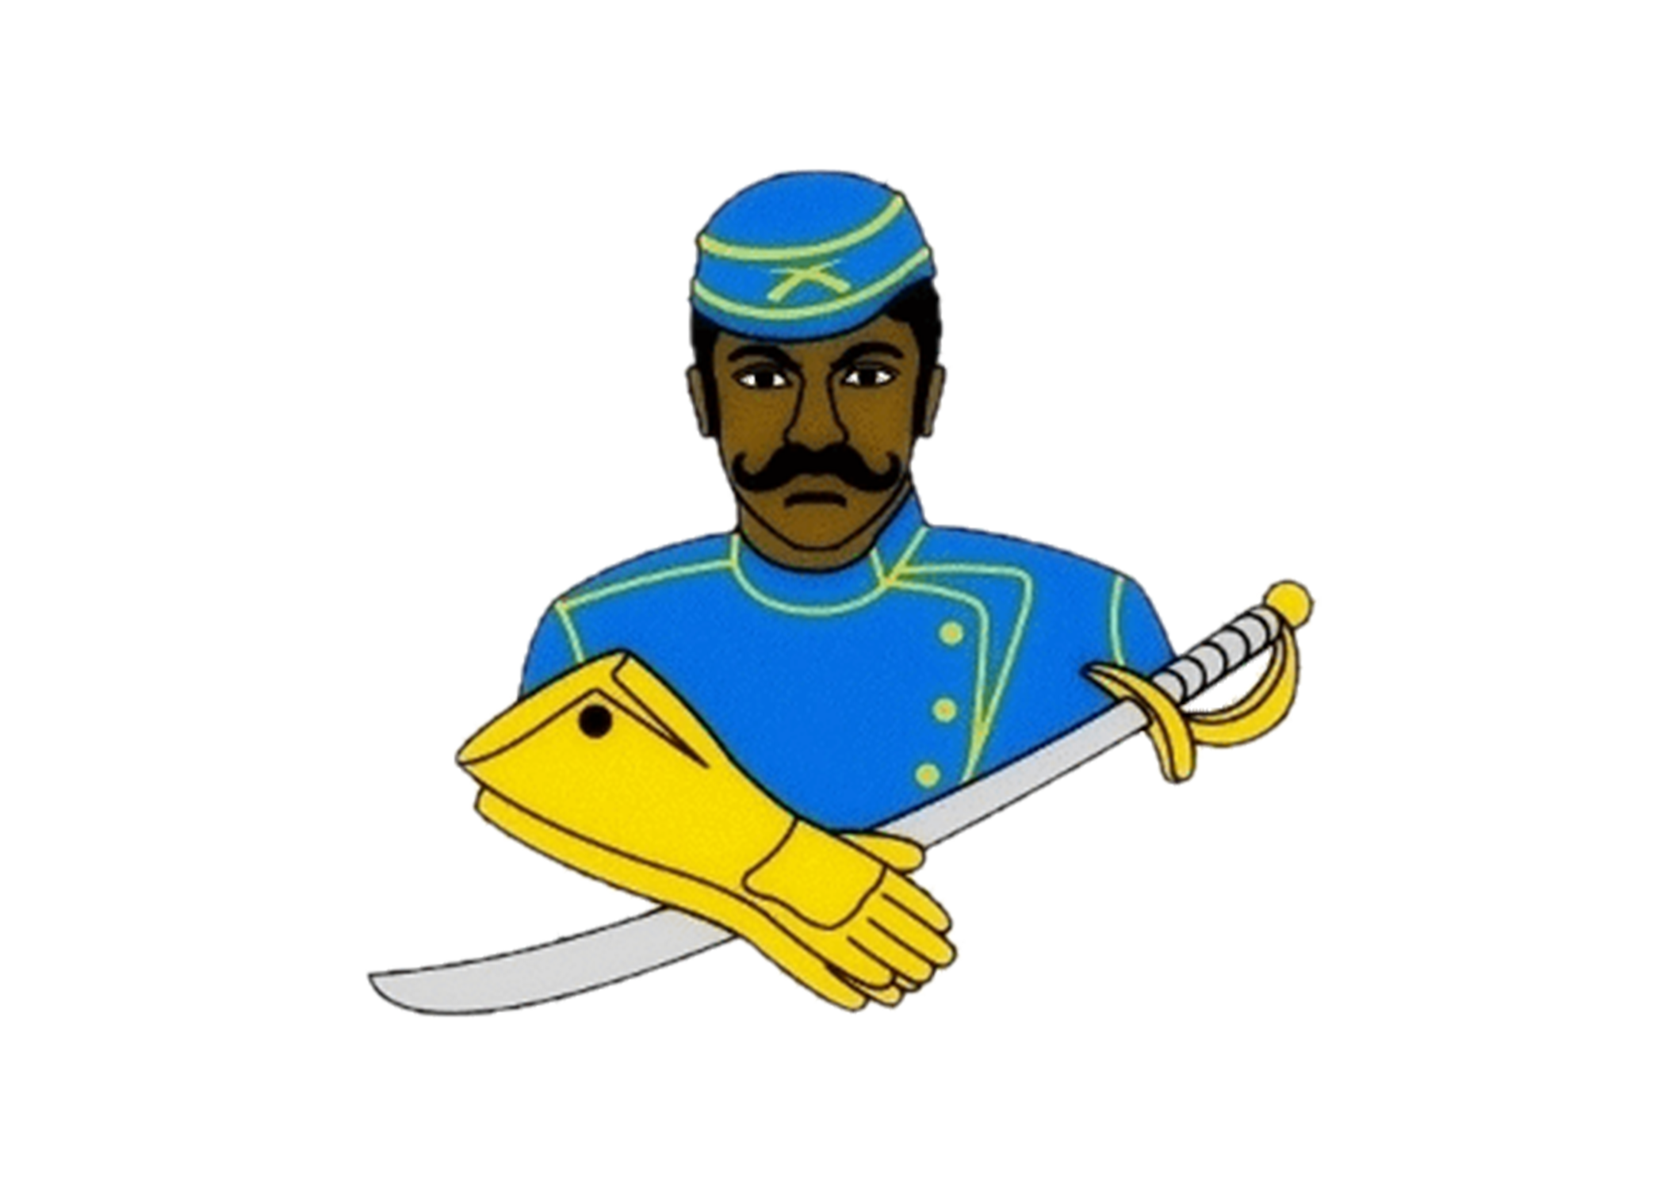
Buffalo Soldiers Motorcycle Club Miami Florida, Inc.
2021 Barry Jennings College Scholarship Application
Application Deadline: April 9, 2021

Name of local Buffalo Soldier Chapter: _Miami, Florida______________________________

Contact Information:
First Name: |  | Last Name:
Address:
City: |  | State:
Zip Code: |  | Email:
Home Phone: |  | Cell Phone:
Date of Birth: |  | Gender:

Academic Information:
High School Name: |  | City / State
Graduation Date: |  | GPA:
Class Rank: |  | Class Size:

College Information (If you have not finalized your college choice, provide your first choice school.):
College Name: |  | City / State:
Institution Type:
Certificate Four-Year Two-Year Vocational or Technical:
Degree Sought: Associates Bachelors Certificate
Major:
Anticipated Graduation Date:

Applicant Service, Extracurricular Activities and Work Experience:

Use this space to provide the applicant’s volunteer service, extracurricular activities and work experience during the applicant’s academic career. Do not attach a resume in lieu of completing this form. It will not be reviewed.

Description
Total Hours or Average Hours per week: |  | Are you still participating? (yes / no)
Start Date: |  | End Date :
Highest Position Held:

Description
Total Hours or Average Hours per week: |  | Are you still participating? (yes / no)
Start Date: |  | End Date :
Highest Position Held:

Description
Total Hours or Average Hours per week: |  | Are you still participating? (yes / no)
Start Date: |  | End Date :
Highest Position Held:

Terms & Conditions:

I, , certify, to the best of my knowledge, that the information on this application is complete and accurate. Falsification of any information will cause my disqualification from the scholarship competition.

(1) It is my responsibility to make sure the application process is complete by the required deadline. If not, the application may be disqualified from the scholarship competition and may not be considered for an award.

(2) This application, upon receipt, becomes the property of the program sponsor.

I agree that, if selected as an award winner for the National Association of Buffalo Soldiers and Troopers Motorcycle Club Scholarship Program, the program sponsor or its agents may use my name and likeness and any other information or materials provided in connection with this program for purposes of news, publicity and advertising in all media, including but not limited to print and electronic media, press releases, internet websites and video media.

To comply with the provisions of the Family Educational and Privacy Act of 1974, I hereby grant permission for school officials to release secondary school records and other requested information, if necessary.

If you are under 18, your parent or guardian must also agree to these Terms and Conditions.

Applicant Signature: Date:

Parent Signature: (if applicable)

** Local Chapter/Frontier must acknowledge receipt before sending to National Scholarship Committee.

Chapter__________________________Signature____________________________________________

ESSAY INSTRUCTIONS
On a separate sheet of paper, please submit a typed 500 word (typewritten) essay on one of the following topics:
**Do not write about the Buffalo Soldiers or Troopers Motorcycle Club**
- What impact did the Buffalo Soldiers make in war and/or peacetime? Why is it necessary to pass this legacy on to future generations?

- Provide specific examples of how the Buffalo Soldiers facilitated the development of roadways, national parks, and mail service.

- The Congressional Medal of Honor is presented to the recipient by the President of the United States in the name of Congress. Please provide a brief narrative regarding a Buffalo Soldier that received this honor and what can be learned from his life, efforts, and commitment to duty.

COMPLETED APPLICATIONS MUST BE SCANNED AND EMAILED BY April 09, 2021 11:59PM EST
Buffalo Soldiers Motorcycle Club
Miami Florida Chapter, Inc.
2021 Barry Jennings College Scholarship Application Checklist
CHECKLIST FOR APPLICANT USE ONLY
DO NOT RETURN CHECKLIST WITH APPLICATION
________ One (1) Official transcript, with a minimum unweighted GPA of 3.0
________ One (1) letter of recommendation on official letterhead from a teacher/guidance counselor/school
administrator

________ One (1) letter of recommendation on letterhead from community service organization
________ Essay completed (500 words typed) (Indicate essay submitted)
________ Signed release form by applicant and parent/guardian if under 18 years of age.
________ School involvement and community services
________ Prepare a letter of introduction; who you are, your accomplishments, to include
honors and awards to date, family background, and the degree to which you are seeking, and financial need. Provide a brief summary on how you plan to use the scholarship, if selected.

________ 4” X 6’’ recent professional headshot photograph
________ A letter of acceptance to an institution of higher learning
________ Application completed and emailed to scholarships@bsmcmiamifl.com. by April 09, 2021
Application is to be typed (this application is an interactive document which allows you to type into the document and it can be retrieved from our website at www.bsmcmiamifl.com or you can email ldbanks001@gmail.com to request a copy.)

Please contact Lenora Banks, Scholarship Chairperson at ldbanks001@gmail.com or 954-609-6961 with questions regarding our scholarship program

